 |  |  |  | DISTRIBUTION
PROJECT | UNR-Mathewson | REPORT # | 002
LOCATION | Reno, NV | TRIP DATE | 10/16/2023
PROJECT # | A9941.01 | ENGINEER/Observer | Hannah Bonotto
CLIENT | LMN Architects | TODAY’S DATE | 10/19/2023
CONTRACTOR | Clark Construction | PAGE | 1 OF 7

OBSERVATIONS/ACTIVITY
Time: 9:00 am
Weather: Clear and 70 °F
Present: Clark Construction – Brian Peart
Magnusson Klemencic Associates – Hannah Bonotto

Clark and MKA walked the UNR Mathewson site to observe the reinforcement in the shear walls at Level 1 of the north core and mat 2, as shown in Figures 1 and 2, prior to the placement of concrete.

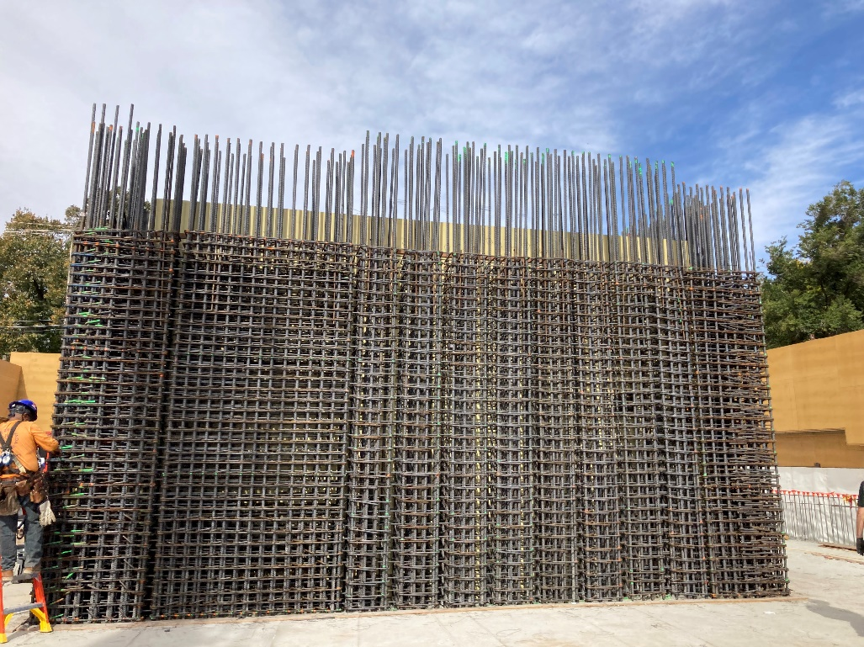
Figure 1. View looking north of Level 1 shear wall reinforcement along Grid 4

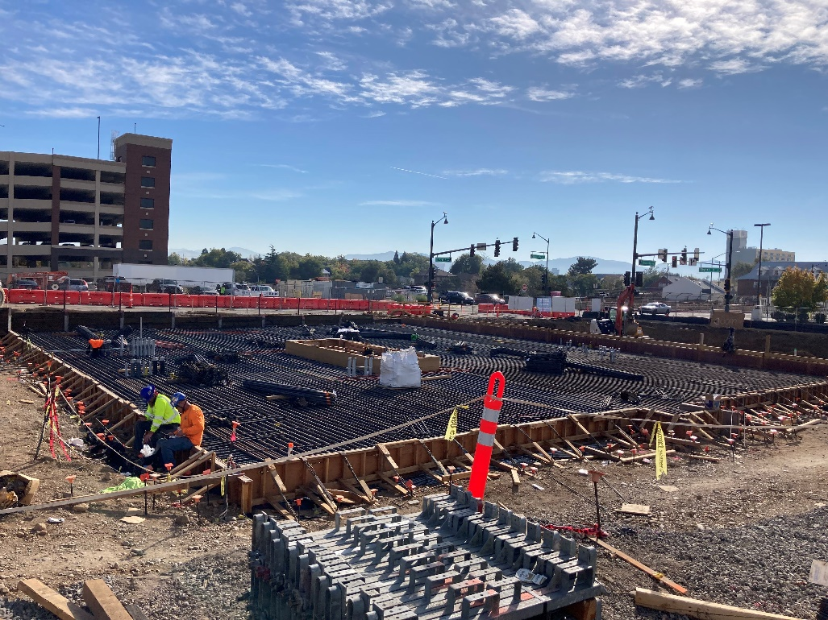
Figure 2. View looking southeast of mat 2 reinforcement

- MKA observed the in-progress reinforcement at the shear walls at Level 1 of the north core. The vertical reinforcement and shear ties were installed prior to MKA’s visit. The horizontal reinforcement was being installed at the time of the visit. The in-place reinforcement appeared to be in conformance with the contract documents.  Action: None | 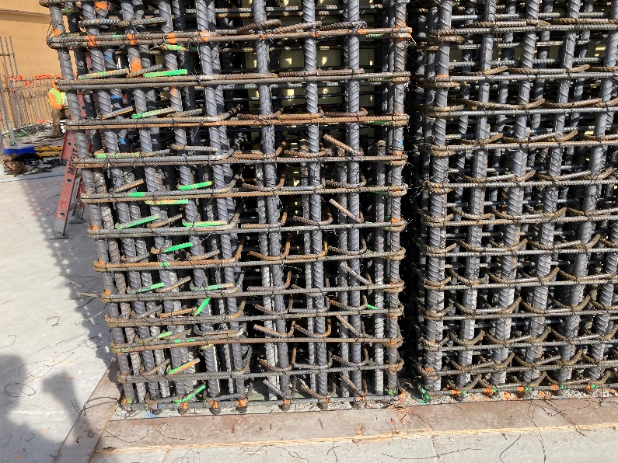  Figure 3. View of southwest corner of north core
- At the bottom of the east wall of the north core, there was (1) #6 horizontal bar that was not able to be fed into the wall due to the dowel placement (see arrow). At this location only, it is acceptable for the horizontal bar on each side to stop at the dowel. Reinforcement will not lap at this location.  Action: No action at this location. At other similar locations, contractor to submit condition to MKA to review prior to omitting reinforcement. | 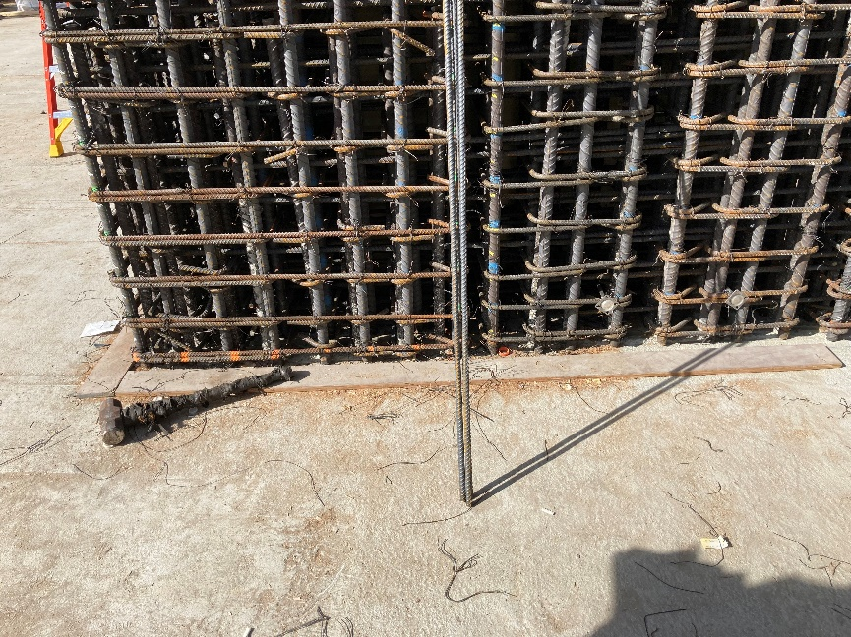  Figure 4. View east wall with bottom horizontal conflicting with vertical dowel
- The installation of the embeds for the Level 2 steel framing was in progress at the time of the visit. MKA discussed the construction tolerances with the contractor.  Action: Within the depth of the embeds, it is acceptable to shift the horizontal reinforcement and the cross ties/hoops. The maximum spacing at each horizontal element should not exceed the specified spacing plus 2”. No reinforcement should be removed or cut. This will result in tighter spacing at some bars and larger spacing at others. This only applies within the depth of the steel embeds. | 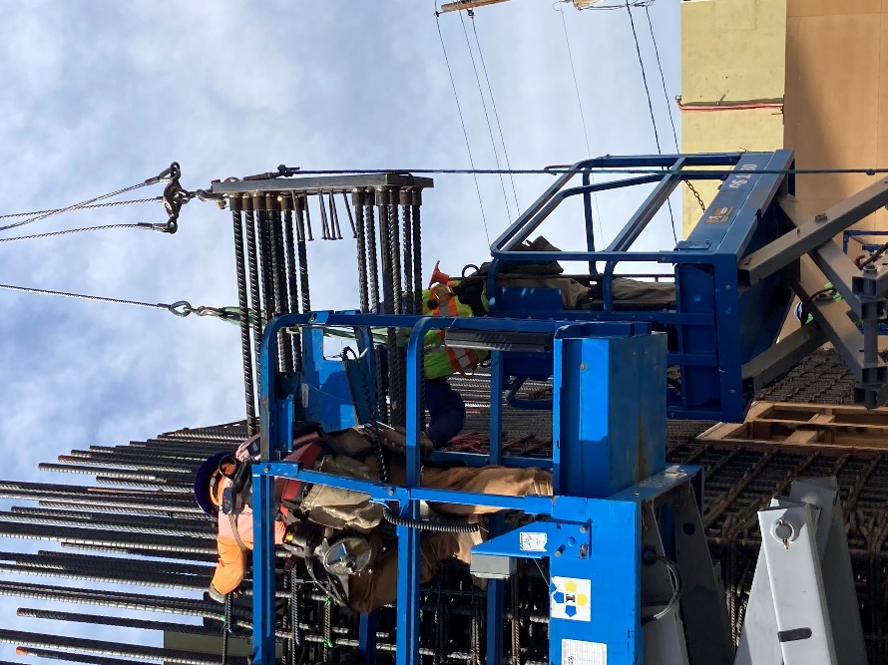  Figure 5. Installation of the northeast Level 2 embed
- MKA observed a C28 embed that had not yet been installed. This embed was missing multiple headed studs. Through conversation with Clark, MKA understands that the studs were in place when the embed arrived on site. It is unclear when and how the studs fell off the embed plate.  Action: Missing studs are to be rewelded to the embed plate per approved AWS welding procedures for headed studs.  The missing studs at this plate cause concern for the integrity of the headed stud attachments at other embed plates. Contractor / inspector to ensure the headed studs are adequately attached to the embed plates at other locations.  Inspector to provide confirmation that headed studs (both shop and field installed) have been inspected per IBC section 1705.2 and AISC 360 Table N5.4-2. | 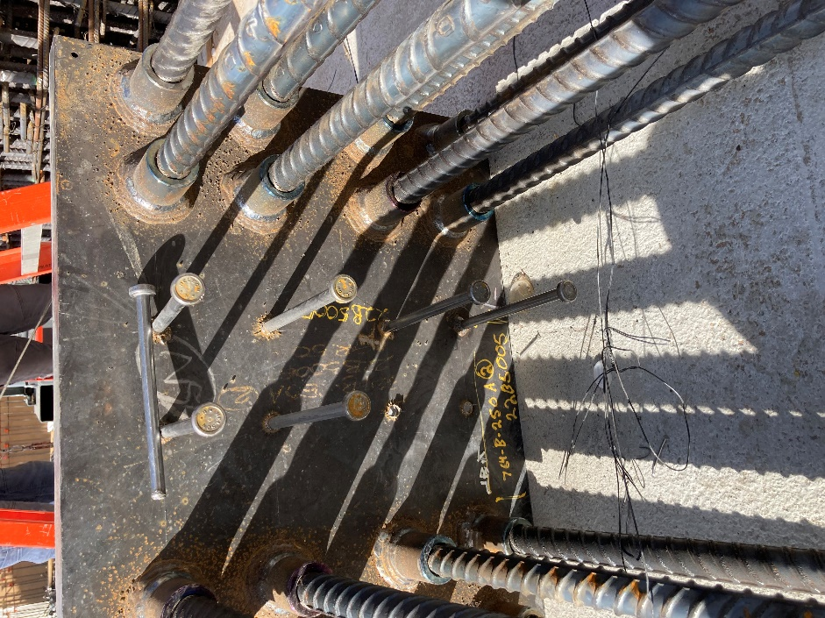  Figure 6. C28 embed with missing studs
- MKA observed the reinforcement at mat 2. Reinforcement installation was in progress. No vertical reinforcement was in place at the time of the visit. The reinforcement appeared to be in conformance with the contract documents.  Action: None. | 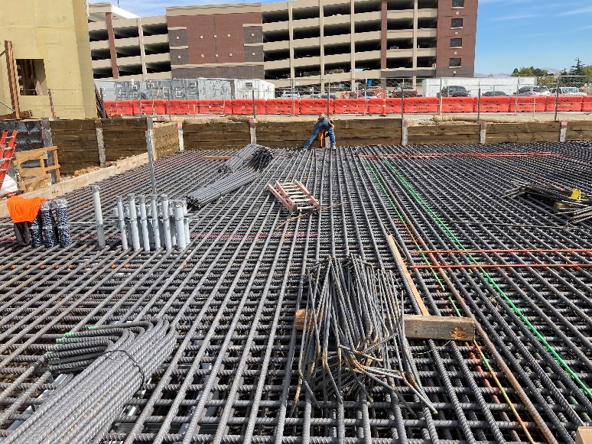  Figure 7. Reinforcement at mat 2
- MKA observed the conduit and pipe routing within the depth of the mat foundation. The piping was within the middle third of the mat depth and appeared to be spaced per the contract documents.  Action: None. | 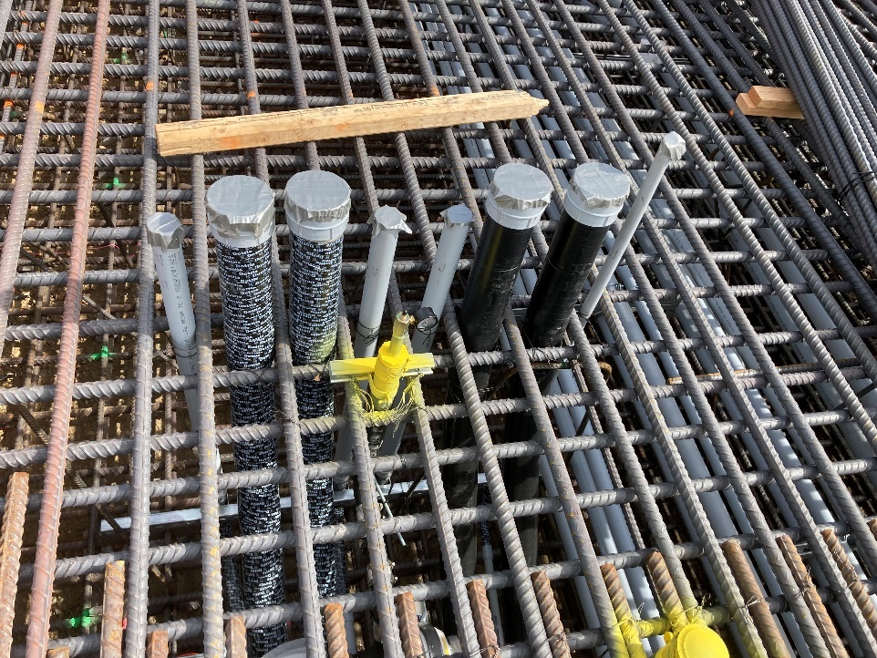  Figure 8. Conduit and pipe penetrations and routing within the depth of mat 2
- MKA observed vertical reinforcement extending above Level 2 to lap with upper levels. The hooked slab reinforcement and formsavers were not installed at the time of the site visit. MKA understands this will be installed prior to concrete placement.  Action: None. | 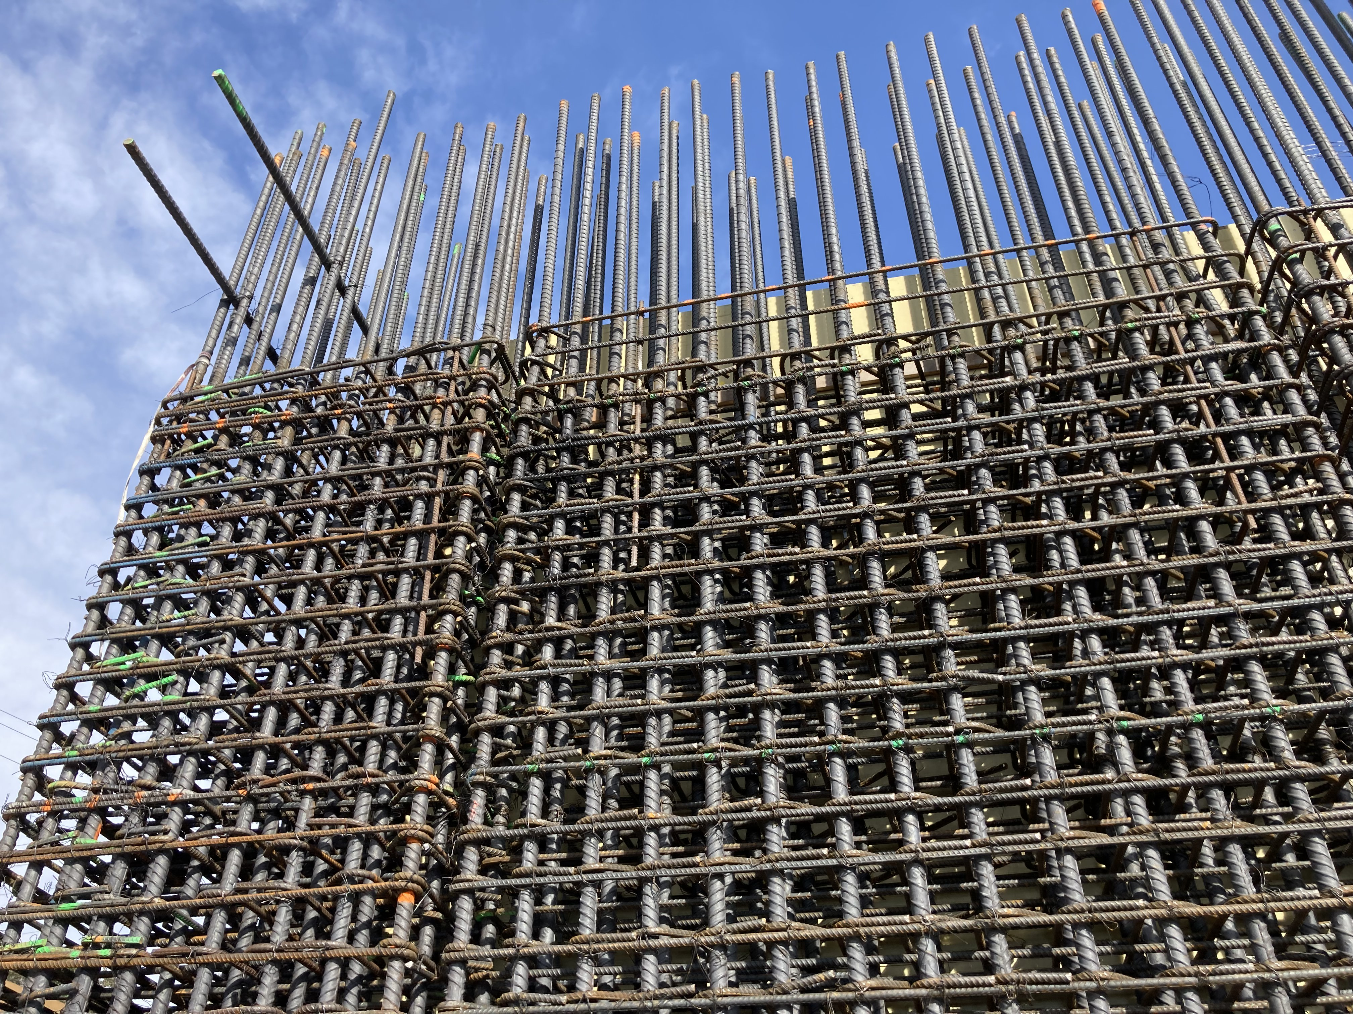  Figure 9. Reinforcement at top of level 1 at north core

I:\UNR_Mathewson\Construction Admin\FieldReports\20231019_UNR_MKA Construction Observation Report_002.docx

